
A 12
Set No : 1

Sreenidhi Institute of Science & Technology
(An Autonomous Institution)
Code No: 121MA01

B. TECH. I – Year I – Semester Examinations, February, 2014 (Regular/Suppli.)
ENGINEERING MATHEMATICS – I ( Common to EEE, ECE & IT )

Time: 3 Hours Max. Marks : 70

Note : No additional answer sheets will be provided.

Part-A (Objective Type)
Max.Marks:20

Answer all QUESTIONS.

- Show that the sequence 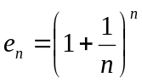 is bounded and increasing.
- Show that the series 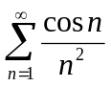 is convergent
- Find the maximum and minimum values of 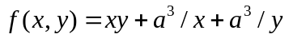.
- Let 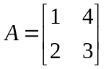. Find the Eigenvalues of matrix 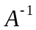.
- Let 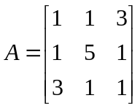 , then find the Eigenvalues of transpose of A.
- Define linearly independent vectors and give an example.
- Explain Echelon form of a matrix.
- Calculate by double integration, the volume generated by the revolution of the Cardioid 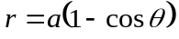 about its axis.
- Evaluate 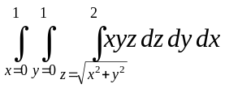.
- If A = 5t²i +tj, B= sinti – costj, find A.B

Part – B
Max. Marks: 50
ANSWER ANY FIVE QUESTIONS. EACH QUESTION CARRIES 10 MARKS.

- (a) Explain Raabe’s test. Test for the convergence of the series 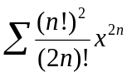 [5]
(b) Explain Cauchy’s root test. Test for the convergence of the series
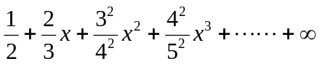. [5]
- (a) Find the maximum and minimum distances of the point (3,4,12) from the sphere 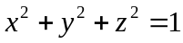. [5]
(b) If 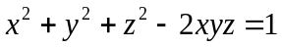, show that 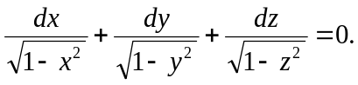 [5]
- (a) If u, v are functions of two independent variables x and y. Then write two important properties of Jacobian of u, v with respect to x, y. [5]
(b) If 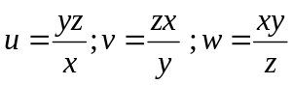 , then find 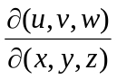. [5]
- (a) Write the statement of Cayley-Hamilton theorem. [3]
(b) Find the Eigenvalues, Eigenvectors of the matrix 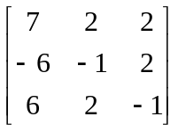. [7]
- (a) Define normal form of a matrix and rank of a matrix. [3]
(b) Reduce the following matrix into its normal form and hence find its rank
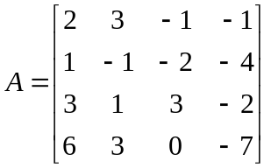 [7]
- (a) Evaluate 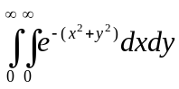 by changing to polar co-ordinates. Hence show that 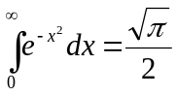. [5]
(b) Evaluate the integral 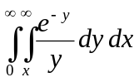 by changing the order of integration. [5]
- (a) Verify Green’s theorem for 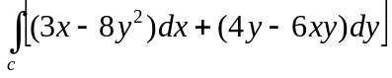 where c is the
boundary of the region bounded by 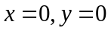 and 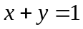. [5]

(b) Using Stokes theorem evaluate 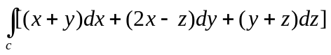 where c
is the boundary of the triangle with vertices (2,0,0), (0,3,0) and (0,0,6). [5]

8. (a) State Gauss Divergence theorem. [3]
(b) Evaluate 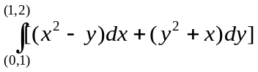 along a straight line from (0,1) to (1,2).
[7]
-- 00 -- 00 --

